**Project Design Phase-II**

**Data Flow Diagram & User Stories**

| Date | 31 January 2025 |
| --- | --- |
| Team ID | TrafficTelligence: Advanced Traffic Volume Estimation With Machine Learning |
| Project Name | LTVIP2025TMID41777 |
| Maximum Marks | 4 Marks |

**Data Flow Diagrams:**

A Data Flow Diagram (DFD) is a traditional visual representation of the information flows within a system. A neat and clear DFD can depict the right amount of the system requirement graphically. It shows how data enters and leaves the system, what changes the information, and where data is stored.



**Example:** [**(Simplified)**](https://developer.ibm.com/patterns/visualize-unstructured-text/)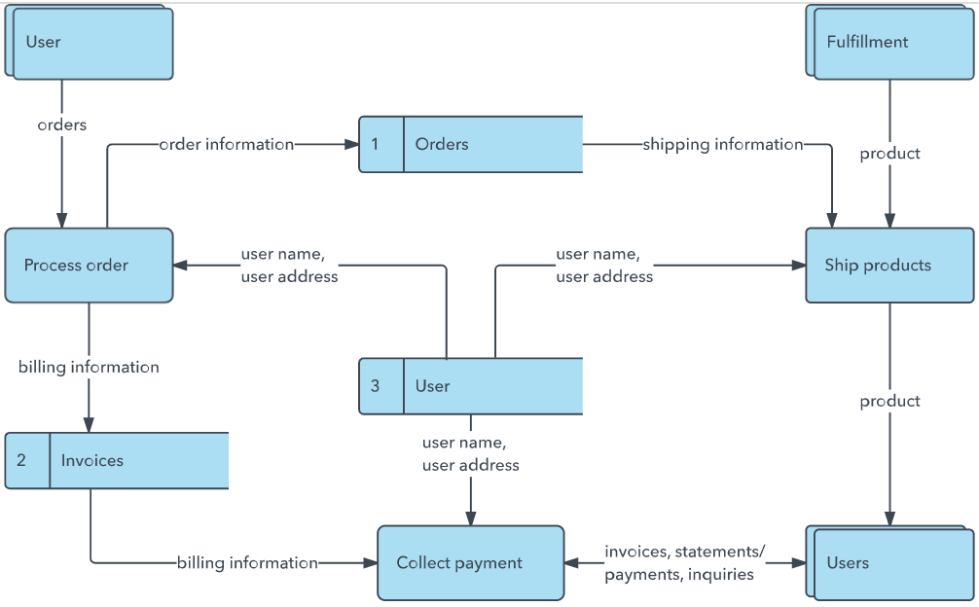

**User Stories**

| **User Type** | **Functional Requirement (Epic)** | **User Story Number** | **User Story / Task** | **Acceptance Criteria** | **Priority** | **Release** |
| --- | --- | --- | --- | --- | --- | --- |
| Traffic Authority | Real-time traffic volume prediction | USN-1 | As a traffic authority, I want to receive real-time traffic volume predictions so I can optimize signals. | System provides live volume data with <10% error, and UI updates every minute. | High | Sprint-1 |
| Urban Planner | Infrastructure planning support | USN-2 | As a city planner, I want future traffic trends to guide new road or transit designs. | System shows predictive traffic maps for at least 1 year into future based on current dataset. | High | Sprint-1 |
| Commuter | Personalized traffic navigation | USN-3 | As a commuter, I want route suggestions based on predicted traffic. | Application provides route suggestions with estimated travel times and alternative paths. | Medium | Sprint-2 |
| Developer | Machine Learning Model Development | USN-4 | As a developer, I want to preprocess and train the model with traffic data. | Model is trained with accuracy >85%, no missing values, data scaled and split correctly. | High | Sprint-1 |
| Developer | Web App Development using Flask | USN-5 | As a developer, I want to create a user interface to input data and view predictions. | Flask app runs locally, accepts inputs, and displays model output on screen. | High | Sprint-1 |